# Introduction

Verdegro Display Control is an app for Android. Later there will also be releases for iOS and Windows Phone. With this app you can control the latest generation of Verdegro LED screens. The app is developed to run on a tablet, but will also run on a phone.

Inhoud

Introduction 1

Starting the App 3

Direct Connect 3

Status 4

Edit Show 6

Options 9

# Starting the App

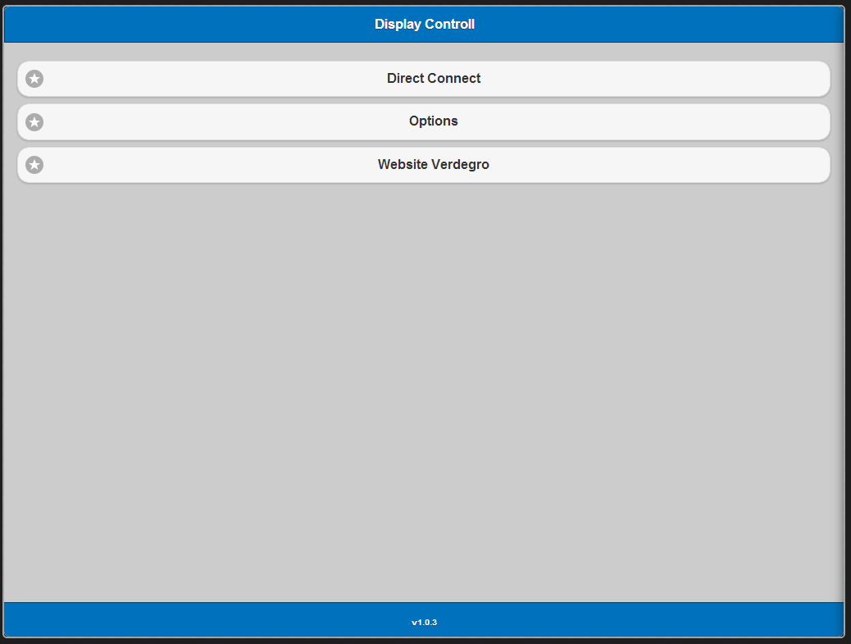

When you start the app you will see the above information on your screen. This is the main menu.

When you are not connected to a network the app will fail to start. You are asked to connect to a network first and restart the app.

Direct Connect

Direct connect is used when your device is directly (by wifi) connected to the LED-screen. After testing if the LED screen is found you will see this screen.

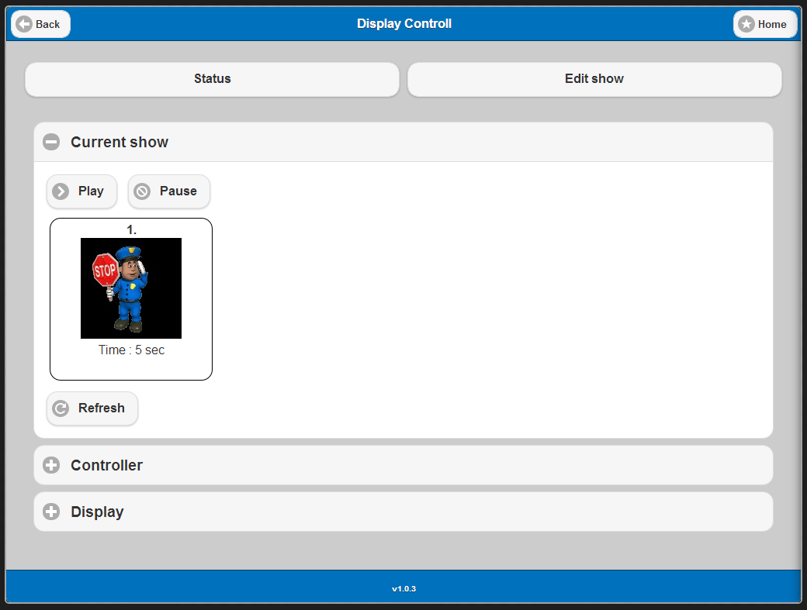

The first time this screen is loaded all the information will be pulled from the screen. After this you can choose between to options:

* Status (Default)
* Edit show

## Status

On the status screen you can see the current status off the screen. On the first part (Current show) you can see the current show which is loaded into the player. (see above)

On the second part (Controller) you can see the status of the controller. Like the brightness and powermode.

The Third part (Display) gives some infommation about the screen. Like size, name, and if available defect pixels.

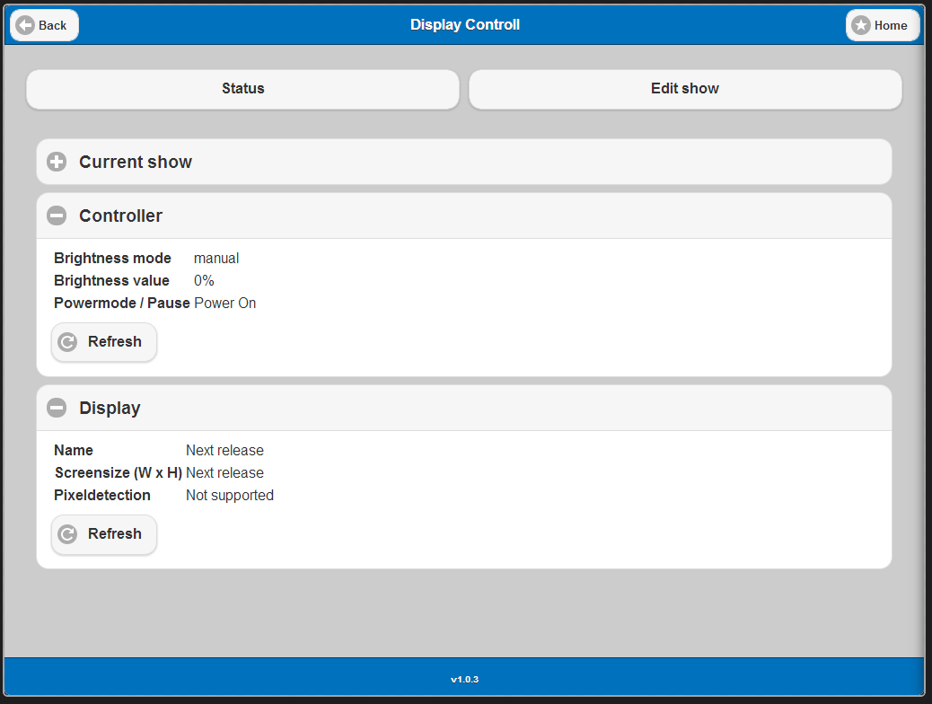

## Edit Show

With edit show you are able to make a new show and send this show to the screen. A show consists of serveral slides (max 10). Each slide contains an image which will be displayed for serveral seconds.

You can select select images from the local library. To get images into the local library you have to get them from your global library on the portal.

The first part of the Edit show page is the show editor.

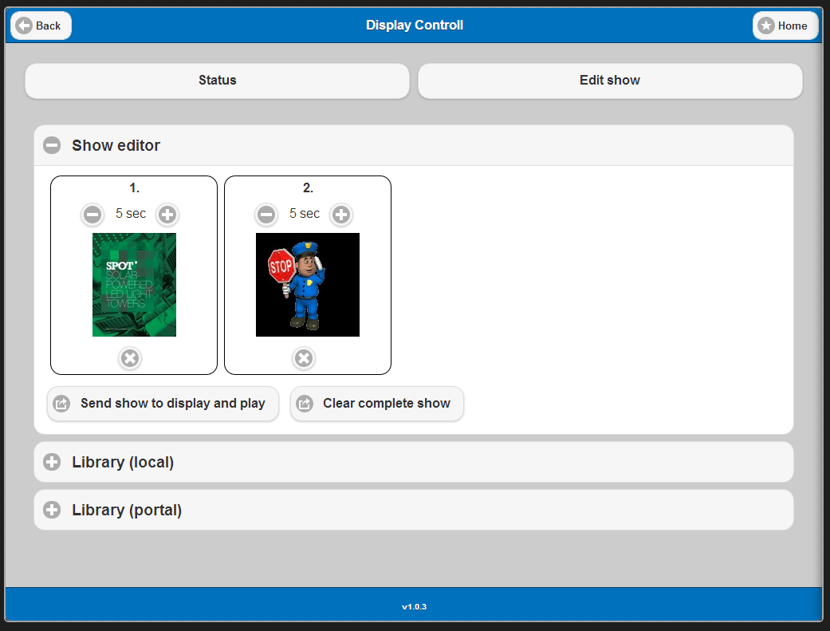

With the show editor you can edit the duration a images/slide is displayed. Or remove a images form the show or a complete show.

After completing the show you can send the show to the display.

Note: After closing the app, the latest show will keep in memory.

The second part is the local library. Images can be added to the local library form the global library (see below)

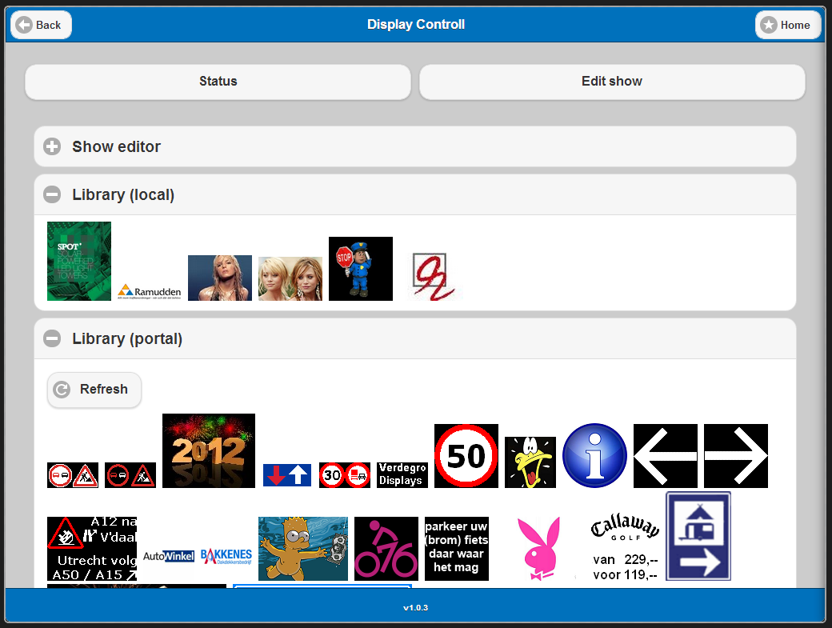

If you tab on an image in the local library you get the following options.

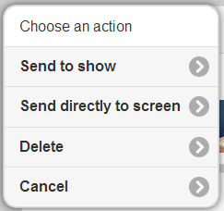

*Send to show:*The tabed image will be added to the show in the show editor. It wil get the default time.

*Send directly to screen*  
The tabbed image will bes end directly to the screen. Only this image will be displayed, this is a sort of a shortcut. It will send a one image show to the display. The show in “edit show” will not be affected.

*Delete*  
Deletes the tabbed image

*Cancel*  
Cancels the action screen (can also be canceld by tabbing next the the action screen)

The thid part is the portal library. For this library to work you have to be connected to the Internet. The app connects to the Verdegro Portal (with the credentials specified under options). And gets a list of available images. To upload images to the portal we refer to another manual.

If you tab on an portal library image you get the following options.

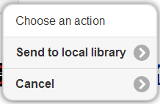

*Send to local library*  
Downloads an image for the portal and places it in the local library.

*Cancel*  
Cancels the action screen (can also be canceld by tabbing next the the action screen)

# Options

In the option stage you can set some options that will be used by the app.

*Language*

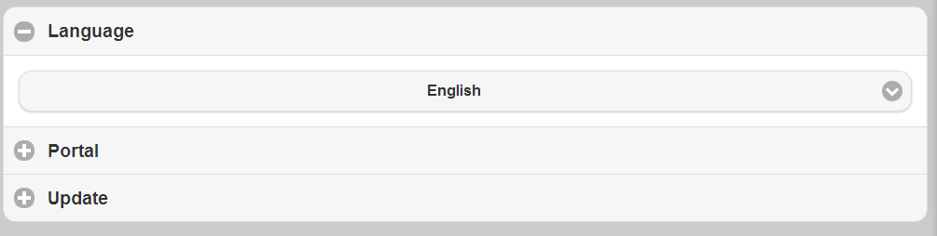

Here you can set your language. The default language is English. If your language is not available please contact Verdegro. We will send you a file to translate and with the next update this translation will be added to the app.

*Portal*

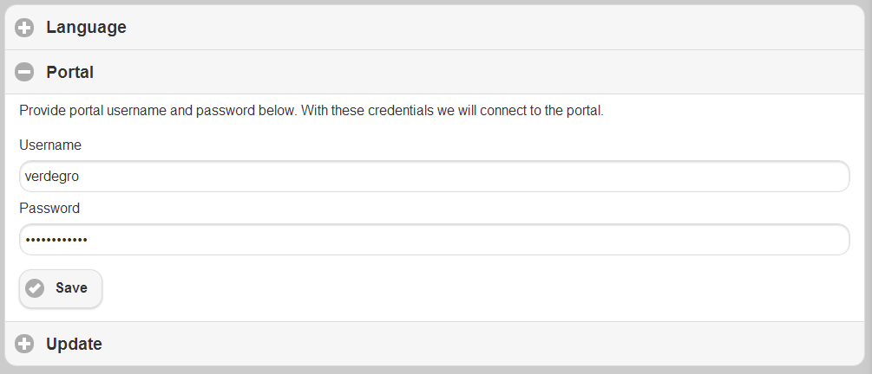

In the portal part you can specifiy your username and password. These credentials will be used if the app has to connect to the portal. For example to get images form the library.

*Update*

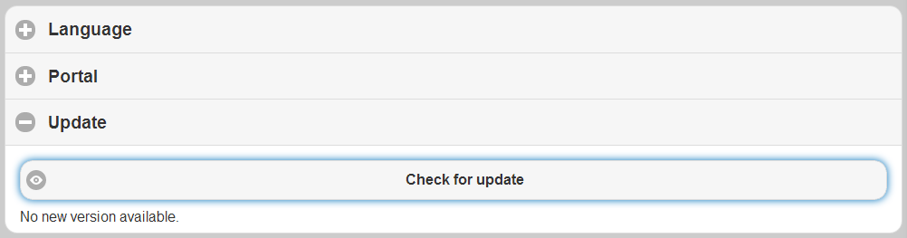

This app is under continues development. To provide you with the latest version we have made an update function. Tab the Check for update button to see if a new version is availabe.

If a new version is available a download button will apear. After tabbing this button, the latest version will be downloaded and installed. All settings remain intact.

This function requires an Internet connection.